Dominic Bumpus UML Exercise
Dominic Bumpus
Trine University
SYS—5013-301
Dr. Kelly Wibbenmeyer
September 28, 2025

Introduction
Unified Modeling Language (UML) is a standard approach in systems analysis and design that helps turn complex requirements into a visual, structured model. Readers’ Haven, an online bookstore, requires a system capable of managing book purchases, rentals, customer reviews, user profiles, and personalized recommendations. To achieve this, a UML diagram has been made that captures the structure and relationships of the system’s major entities. The diagram and explanation show how the bookstore’s requirements are turned into a simple design that ensures scalability, modularity, and effective management of operations.

UML Class Diagram Overview
The UML diagram for Readers’ Haven is centered on five main components. These components are User Profiles, Catalog Management, Transactions, Customer Feedback, and the Recommender System. Each component consists of classes with defined attributes and methods, and the relationships among them reflect real-world interactions.

1. User Profiles
Classes: User, Customer, Admin
Attributes:
    - User: UserID, Name, Email, Address, ReadingPreferences
    - Customer: inherits from User
    - Admin: inherits from User
Methods: updateProfile(), viewRecommendations(), manageContent() (Admin only)
Relationships:
    - User is a parent class with inheritance to Customer and Admin.
    - Each user may have multiple transactions and feedback entries.

2. Catalog Management
Class: Book
Attributes: BookID, Title, Author, Genre, Price, Availability
Methods: updateAvailability(), viewDetails()
Relationships:
    - Books are associated with transactions (purchase or rental).
    - Books are also linked with reviews (feedback).

3. Transactions
Class: Transaction
Attributes: TransactionID, TransactionDate, Type (Purchase/Rental), TotalAmount
Methods: processTransaction(), generateReceipt()
Relationships:
    - Association with User (customer who made the transaction).
    - Association with Book (book purchased or rented).

4. Customer Feedback
Class: Review
Attributes: ReviewID, Rating, Comment
Methods: submitReview(), editReview()
Relationships:
    - Association with User (reviewer).
    - Association with Book (reviewed book).

5. Recommender System
Class: Recommendation
Attributes: RecommendationID, SuggestedBooks (list)
Methods: generateRecommendations(), updateRecommendations()
Relationships:
    - Aggregation with User (customer reading history and preferences).
    - Dependency on Transaction and Review data for recommendation generation.

UML Diagram Representation
The class diagram illustrates inheritance, associations, and aggregation:
    - Inheritance: Customer and Admin inherit from User.
    - Associations: Transaction links User and Book; Review links User and Book.
    - Aggregation: The Recommendation system aggregates user activity data.
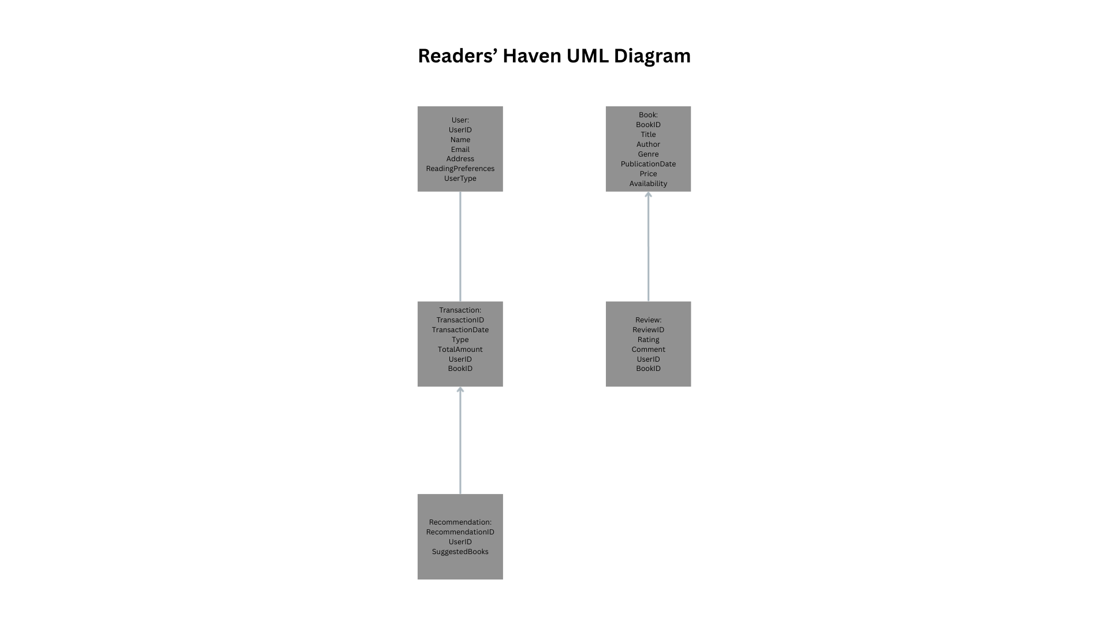

Design Justification
The design choices that were made reflect both system requirements and industry-standard modeling practices. Inheritance was used for User, Customer, and Admin to avoid duplication and promote code reuse. Associations were chosen for Transaction and Review to show the direct relationship between users and books. Aggregation for the recommender system ensures that recommendations are reliant on, but do not directly own, user or transaction data. This decision helps support modularity which allows the recommendation engine to evolve independently. The Book class serves as a central entity since most operations, such as transactions, reviews, and catalog browsing, revolve around books. The overall design captures the bookstore’s major functions while ensuring that additional features, such as loyalty programs or e-book licensing, can be easily integrated in the future.

Conclusion
The UML diagram for Readers’ Haven focuses on effectively modeling the bookstore’s requirements by clearly defining entities, attributes, and relationships. The modular design ensures maintainability, scalability, and useability, with customer focused features such as personalized recommendations and feedback integration. This model supports current needs and positions the system to expand as Readers’ Haven grows.

References
GeeksforGeeks. (2025, August 28). Unified Modeling Language (UML) diagrams. GeeksforGeeks. https://www.geeksforgeeks.org/system-design/unified-modeling-language-uml-introduction/
GeeksforGeeks. (2025, July 12). ObjectOriented Analysis and Design(OOAD). GeeksforGeeks. https://www.geeksforgeeks.org/software-engineering/object-oriented-analysis-and-design/
Kendall, K. E., & Kendall, J. E. (2024). Systems Analysis & Design. Pearson.

